**INDEXING USING Mongodb**

**Name : Umair khan**

**Roll No : 16**

**BEFORE INDEXING**

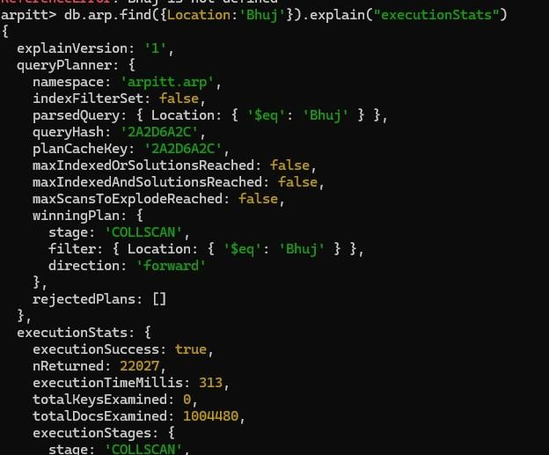

**AFTER INDEXING**

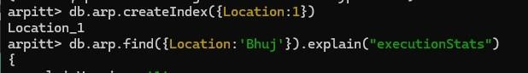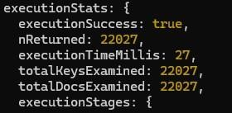

**Key Di erences:**

Winning Plan:

Before Indexing: COLLSCAN (Collection Scan) After Indexing: IXSCAN (Index Scan)

Execution Time:

Before Indexing: 313 milliseconds After Indexing: 27 milliseconds

Total Keys Examined:

Before Indexing: 0 (No index was used, so no keys were examined) After Indexing: 22,027

Total Docs Examined:

Before Indexing: 1,004,480

After Indexing: 22,027

Overall, indexing significantly improved the query performance by reducing the execution time and the number of documents examined. It e ciently utilized the index to find relevant documents, leading to faster query execution.

***To find existing indexes in MongoDB, you can use the getIndexes() method on a collection.***  ***Here's how you can do it***

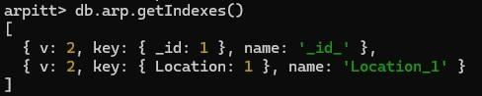

***To drop indexes in a collection in MongoDB, you can use the dropIndex() method. Here's how you can do it:***



***If you want to drop all indexes except the default index on the _id field, you can use the dropIndexes() method:***

